IU2541230060 – CPP39 – PROJECT REPORT

NGO Volunteer Management
Enrollment No.: IU2541230060
Student Name: VEDANSH PATEL
Semester: 3
Subject: C++ Guided Project
GitHub Repository: https://github.com/vedanshpatel25cse-INDUS/NGO-Volunteer-Management.git
1. Introduction
Non-governmental organizations depend on volunteers, yet many small NGOs still track volunteers, events and duties on paper or in scattered spreadsheets. This leads to forgotten contact details, double bookings and no clear picture of who is doing what. The NGO Volunteer Management system is a console-based application written in C++ that keeps this information in one place.
The project is built using Object-Oriented Programming. Volunteers, events, skills and assignments are modelled as classes derived from a common abstract base class. A system class (NGO) coordinates the work, a template container manages dynamic memory, and a FileManager class stores all data in text files so that records survive after the program is closed.

2. Problem Statement
NGOs need a simple and reliable way to record volunteers and their skills, plan events, and assign the right volunteers to events without clashes. Manual methods are error-prone, make searching slow, and lose data easily. The problem is to design and implement a menu-driven C++ program that stores volunteer, event, skill and assignment records, validates every input, prevents duplicate and conflicting assignments, produces reports, and saves all data permanently to files.

3. Objectives
- To apply Object-Oriented Programming concepts (classes, encapsulation, inheritance, runtime polymorphism) to a real-life problem.
- To manage volunteer, event, skill and assignment records using add, display, search, update and delete operations.
- To implement a main transaction that assigns a volunteer to an event while preventing duplicate assignments and same-date clashes.
- To use dynamic memory (new[] / delete[]) to store a growing number of records.
- To provide data persistence using file handling so that records are available after restarting the program.
- To validate user input and handle errors using exception handling.
- To generate a report summarising events, assigned volunteers and idle volunteers.

4. Functional Requirements
- FR1 – Add Record: add a volunteer (name, 10-digit phone, skills), an event (name, date) or a skill (name, level).
- FR2 – Display Records: list all volunteers, events, skills or assignments.
- FR3 – Search Record: search by ID or keyword (name, skill, phone, date, role).
- FR4 – Update Record: modify an existing volunteer, event, skill or assignment role.
- FR5 – Delete Record: delete any record; deleting a volunteer or event also removes its assignments.
- FR6 – Main Transaction: assign a volunteer to an event with a role; reject unknown IDs, duplicates and same-date clashes.
- FR7 – Report: show totals, volunteers per event and volunteers with no assignment.
- FR8 – Save / Load: save to and load from data files; data is loaded automatically at start and saved at exit.
- FR9 – Validation and error handling: reject invalid names, phone numbers, dates and menu choices without crashing.

5. System / Project Flow
The overall flow of the program is:
USER → MAIN MENU (main.cpp) → NGO SYSTEM CLASS → ENTITY CLASSES (Volunteer, Event, Skill, Assignment via Store<T>) → MAIN TRANSACTION (assignVolunteer) → FILE MANAGER → DATA FILES (Data/*.txt)
main.cpp only creates the NGO object and calls run(). At start-up, run() calls FileManager::load() to restore old records. The user then chooses menu options; each option is handled by an NGO member function that validates input, works on the Store<T> containers and prints the result. When the user chooses Exit, FileManager::save() writes all records back to the data files. The program follows the required cycle: START → Load existing records → Perform operations → Save updated records → EXIT.

6. Class Descriptions
Class | Data Members | Member Functions | Responsibility
Record (abstract) | id, name | Record(), Record(id,name), ~Record(), getId(), getName(), setName(), display()=0, serialize()=0, deserialize()=0, typeName()=0 | Abstract base class giving every entity a common id/name and a polymorphic interface.
Volunteer | phone, skills (+ inherited id, name) | Volunteer(), Volunteer(id,name,phone,skills), ~Volunteer(), getters/setters, display(), serialize(), deserialize() | Stores one volunteer's identity, contact number and skill list.
Event | date (+ id, name) | Event(), Event(id,name,date), ~Event(), getDate(), setDate(), display(), serialize(), deserialize() | Represents an NGO activity or campaign held on a particular date.
Skill | level (+ id, name) | Skill(), Skill(id,name,level), ~Skill(), getLevel(), setLevel(), levelName(), display(), serialize(), deserialize() | Master list of skills with a proficiency level (1-3).
Assignment | volunteerId, eventId, role (+ id) | Assignment(), Assignment(id,vId,eId,role), ~Assignment(), assign(), getters, setRole(), display(), serialize(), deserialize() | Links one volunteer to one event with a role; the result of the main transaction.
Store<T> (template) | items (T*), count, capacity | Store(cap), ~Store(), add(), at(), indexOfId(), removeAt(), nextId(), clear(), grow() | Dynamic array built with new[] / delete[]; grows automatically.
NGO (system class) | Store<Volunteer>, Store<Event>, Store<Skill>, Store<Assignment>, dirty | NGO(), ~NGO(), addVolunteer(), addEvent(), addSkill(), assignVolunteer(), delete*(), menuAdd/Display/Search/Update/Delete(), menuTransaction(), report(), saveAll(), loadAll(), run() | Controls the whole system: owns all data, implements every menu option and the main transaction.
FileManager | dir (data folder) | FileManager(), ~FileManager(), save(NGO&), load(NGO&) | Writes and reads the four data files; reports corrupt data with exceptions.
AppException, ValidationException, InputClosedException | (inherit std::runtime_error) | constructors | Exception hierarchy used for validation, logic and file errors.

7. OOP Concepts Used
- Classes & Objects: Volunteer, Event, Skill, Assignment, NGO and FileManager are classes; main() creates an NGO object.
- Encapsulation: Data members are private or protected and are accessed only through getters/setters, e.g. Volunteer::getPhone()/setPhone().
- Constructors (default + parameterized): Every entity has Class() and Class(id, …), e.g. Volunteer() and Volunteer(id, name, phone, skills); Store(cap) and FileManager(dir) are parameterized.
- Destructors: Virtual ~Record() and derived destructors; ~Store() calls delete[] items to release memory; ~NGO() lets its Stores clean up automatically.
- Inheritance: Volunteer, Event, Skill and Assignment inherit from Record; ValidationException and InputClosedException inherit from AppException, which inherits from std::runtime_error.
- Runtime Polymorphism: Record declares pure virtual display(), serialize(), deserialize() and typeName(). NGO::showAll() and FileManager::saveStore() call them through Record* pointers, so the correct derived version runs at runtime.
- Dynamic Memory: Store<T> allocates T* items = new T[capacity], doubles it with grow() when full and frees it with delete[]. Dynamic memory is needed because the number of records is not known in advance.
- File Handling: FileManager uses ifstream/ofstream to save and load volunteers.txt, events.txt, skills.txt and assignments.txt.
- Validation: validateName(), validatePhone(), validateDate(), validateText() and readInt() re-prompt until correct input is entered.
- Exception Handling: try/catch blocks handle AppException, ValidationException and InputClosedException in input helpers, NGO::run() and file operations; invalid IDs, duplicates and corrupt files are reported cleanly.

8. File Handling and Data Persistence
Data is stored in plain text files inside the Data/ folder, one record per line with fields separated by the '|' character:
- volunteers.txt – id|name|phone|skills
- events.txt – id|name|date
- skills.txt – id|name|level
- assignments.txt – id|volunteerId|eventId|role
On start-up, FileManager::load() reads every file line by line, splits it and calls the entity's deserialize() method. A missing file is treated as an empty list (first run). A corrupt line raises an AppException with the file name and line number. On exit (or through menu option 8), FileManager::save() rewrites all files. The '|' character is rejected during input so the file format can never be broken. Test T15 closes and reopens the program and confirms that old records are still available.

9. UML Diagrams
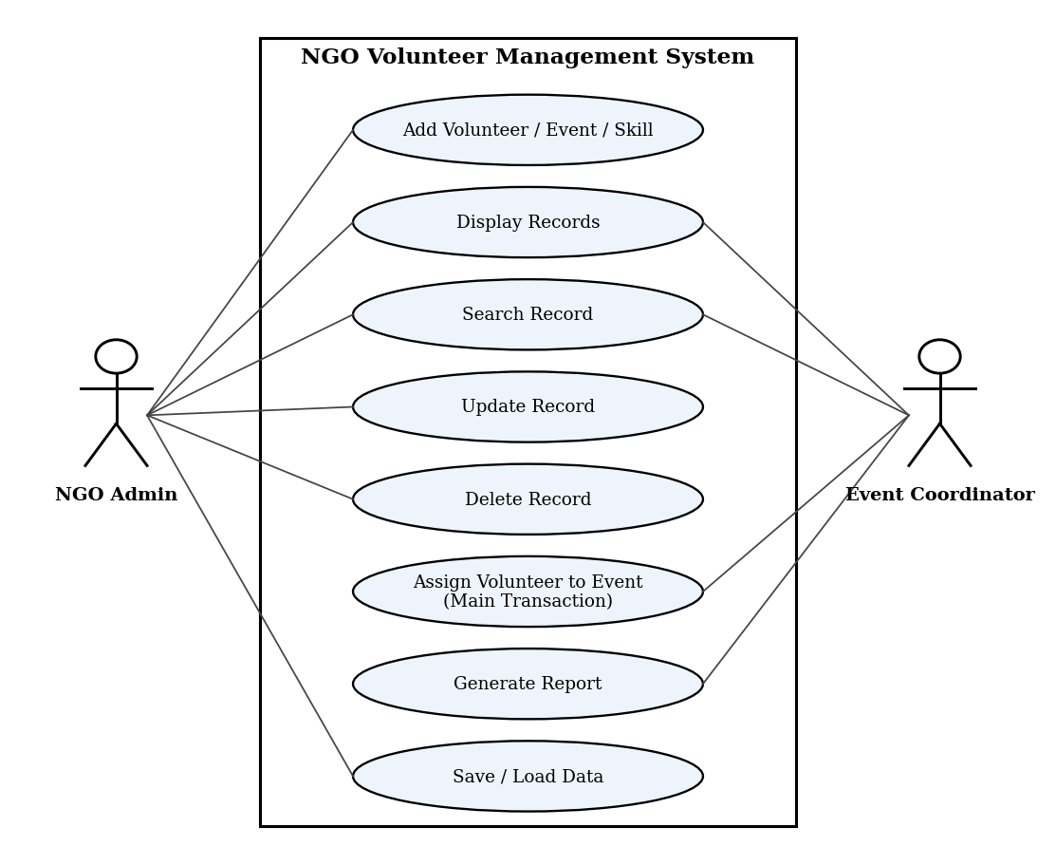
Figure 1: Use Case Diagram (2 actors, 8 use cases)
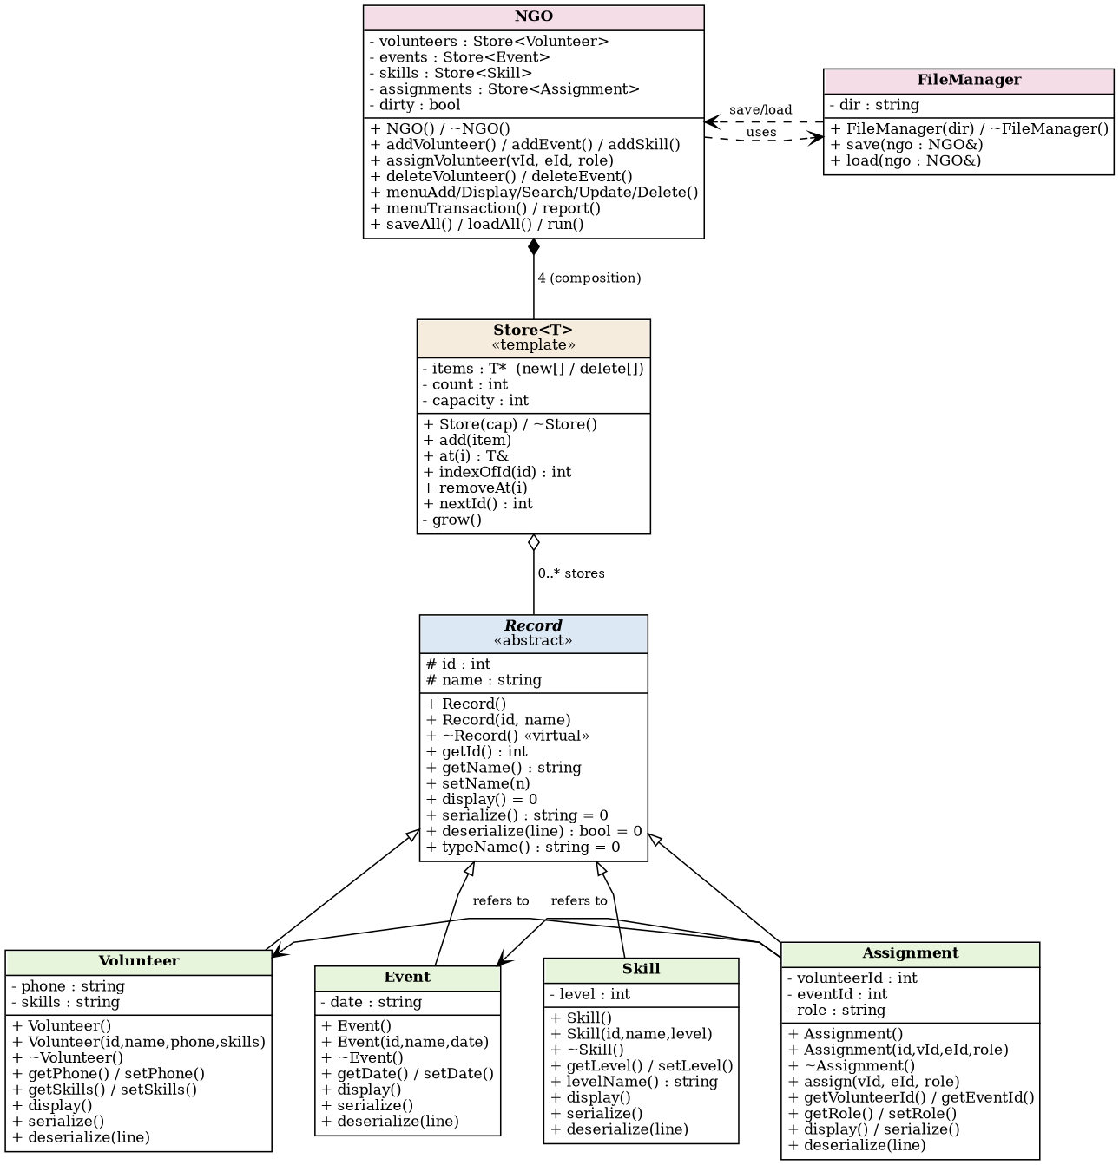
Figure 2: Class Diagram
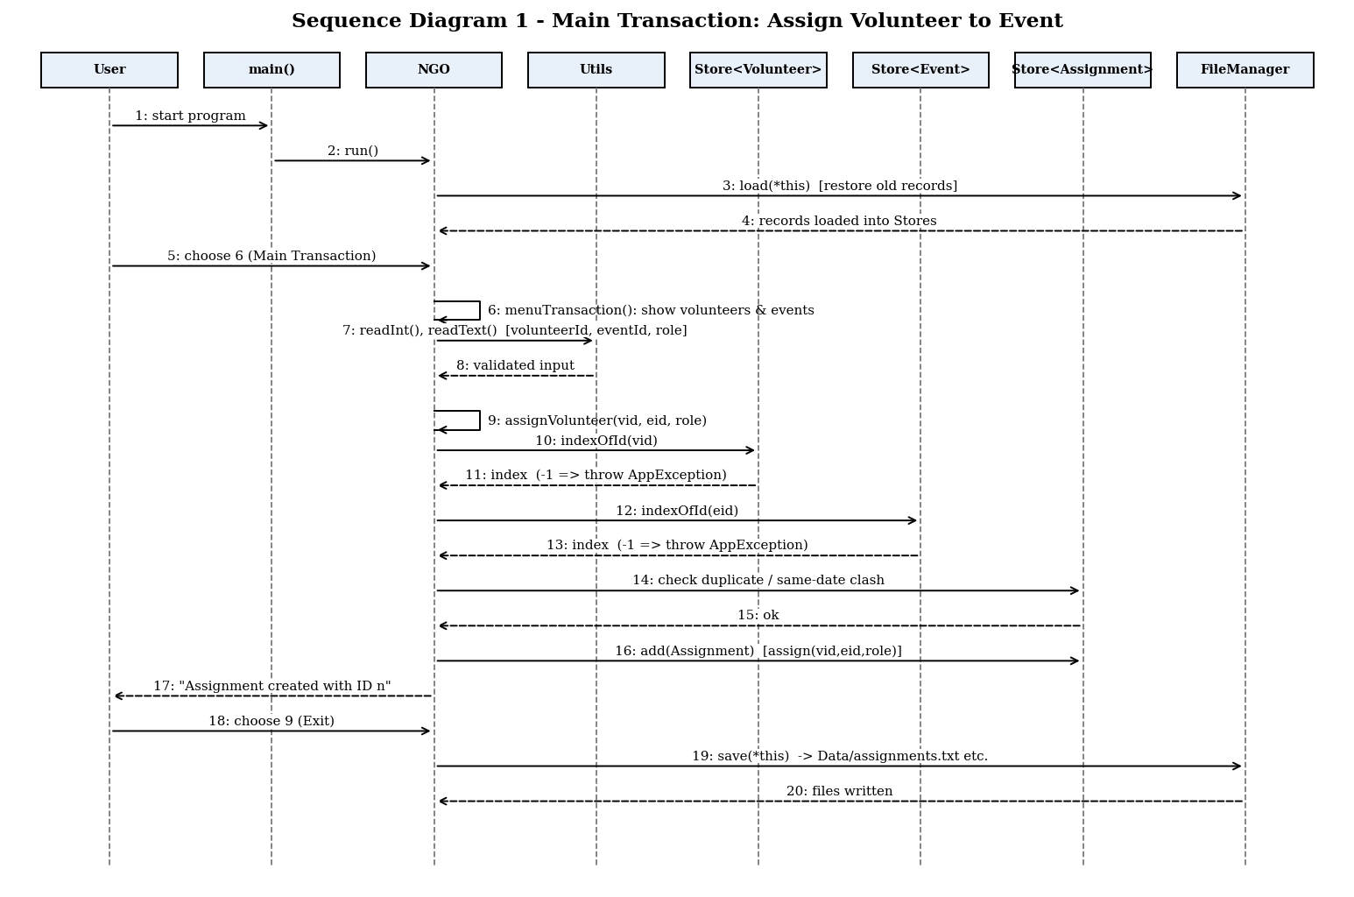
Figure 3: Sequence Diagram 1 – Main Transaction (Assign Volunteer to Event)
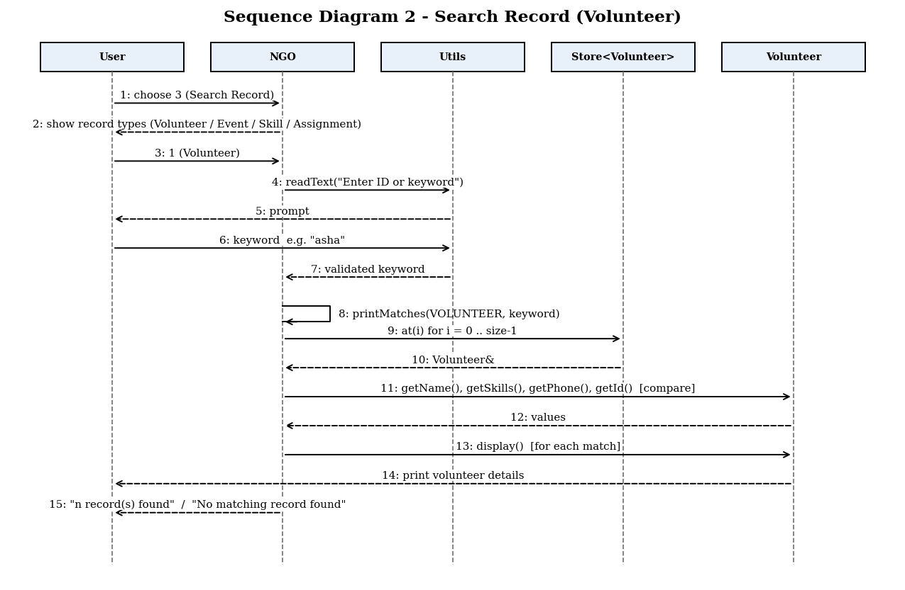
Figure 4: Sequence Diagram 2 – Search Record

10. Implementation Details
The program is written in C++11 and compiled with g++. The source is divided into one header/source pair per class, which keeps main.cpp very small:
- main.cpp – creates the NGO object and calls run().
- Record.h/.cpp – abstract base class.
- Volunteer, Event, Skill, Assignment (.h/.cpp) – entity classes.
- Store.h – template dynamic array.
- NGO.h/.cpp – system class with all menu logic and the main transaction.
- FileManager.h/.cpp – file save/load.
- Utils.h/.cpp – validation, input helpers and exception classes.
Main transaction logic (assignVolunteer): the function (1) validates the role text, (2) checks that the volunteer ID and event ID exist, (3) scans existing assignments of that volunteer to reject a duplicate assignment to the same event, (4) rejects a second event on the same date (a volunteer cannot be in two places at once), and (5) creates an Assignment object, calls assign(), and adds it to the Store<Assignment>. Failures throw AppException, which the menu loop catches and displays.
Memory safety: the program was also compiled with AddressSanitizer and UndefinedBehaviorSanitizer and all 15 tests were re-run; no memory leaks or errors were reported.
Compilation: g++ -std=c++11 main.cpp NGO.cpp FileManager.cpp Record.cpp Volunteer.cpp Event.cpp Skill.cpp Assignment.cpp Utils.cpp -o NGOVolunteer (or simply run make).

11. Testing and Results
Test ID | Input / Operation | Expected | Actual | Status
T01 | Add Volunteer – Name: Asha Patel, Phone: 9876543210, Skills: Cooking | Volunteer added with ID 1. | Matched: Volunteer added with ID 1. | Pass
T02 | Add Volunteer (validation) – Phone '12345' then valid 9876543211 | Phone must be exactly 10 digits.  Volunteer added with ID 1. | Matched: Phone must be exactly 10 digits.  Volunteer added with ID 1. | Pass
T03 | Add Event – Blood Donation Camp, 15/11/2026 | Event added with ID 1. | Matched: Event added with ID 1. | Pass
T04 | Add Event (invalid date) – Date 31/02/2026 then 20/11/2026 | Invalid date (day out of range for month).  Event added with ID 1. | Matched: Invalid date (day out of range for month).  Event added with ID 1. | Pass
T05 | Add Skill – First Aid, level 3 | Skill added with ID 1. | Matched: Skill added with ID 1. | Pass
T06 | Add Skill (duplicate) – First Aid twice (second as 'first aid') | Skill already exists. | Matched: Skill already exists. | Pass
T07 | Display Volunteers – Menu 2 > 1 after adding one volunteer | Volunteers (1)  Asha Patel | Matched: Volunteers (1)  Asha Patel | Pass
T08 | Search Volunteer – Keyword 'asha' | 1 record(s) found. | Matched: 1 record(s) found. | Pass
T09 | Search (no match) – Keyword 'xyz' | No matching record found. | Matched: No matching record found. | Pass
T10 | Update Volunteer – ID 1 -> Asha Mehta, 9876500000, Teaching | Record updated.  Asha Mehta | Matched: Record updated.  Asha Mehta | Pass
T11 | Main Transaction: Assign – Volunteer 1, Event 1, role Coordinator | Assignment created with ID 1. | Matched: Assignment created with ID 1. | Pass
T12 | Assign (duplicate) – Same volunteer + same event again | Volunteer is already assigned to this event. | Matched: Volunteer is already assigned to this event. | Pass
T13 | Assign (date clash) – Volunteer 1 to two events on 15/11/2026 | already booked for another event on this date. | Matched: already booked for another event on this date. | Pass
T14 | Delete Volunteer (cascade) – Delete volunteer 1 then Report | Record deleted.  Total assignments: 0 | Matched: Record deleted.  Total assignments: 0 | Pass
T15 | File persistence (restart) – Add data, Exit, reopen, Display + Report | Existing records loaded  Asha Patel  Total assignments: 1 | Matched: Existing records loaded  Asha Patel  Total assignments: 1 | Pass

All 15 test cases passed. An additional check confirmed that a corrupted data file is reported with a clear message instead of crashing the program.

12. Sample Screens / Output
The complete C++ source code of the program is given first, file by file. After it, each sample screen is shown together with the part of the code that produces it, so that the code and its output can be read side by side. All screens below were produced by this code.
Complete Source Code
● ● ● main.cpp
#include "NGO.h"

int main() {
NGO ngo;
ngo.run();
return 0;
}

● ● ● Utils.h
#ifndef UTILS_H
#define UTILS_H

#include <string>
#include <stdexcept>

// ---------- Colours used for console messages ----------
const std::string GREEN = "\033[92m";
const std::string RED = "\033[91m";
const std::string BLUE = "\033[94m";
const std::string RESET = "\033[0m";

// ---------- Exception hierarchy ----------
class AppException : public std::runtime_error {
public:
explicit AppException(const std::string& msg) : std::runtime_error(msg) {}
};

class ValidationException : public AppException {
public:
explicit ValidationException(const std::string& msg) : AppException(msg) {}
};

class InputClosedException : public AppException {
public:
InputClosedException() : AppException("Input closed.") {}
};

// ---------- Validation helpers (throw ValidationException) ----------
void validateName(const std::string& s);
void validateText(const std::string& s, const std::string& what);
void validatePhone(const std::string& s);
void validateDate(const std::string& s);

// ---------- Input helpers (re-prompt until the input is valid) ----------
std::string readLine(const std::string& prompt);
int readInt(const std::string& prompt, int lo, int hi);
std::string readName(const std::string& prompt);
std::string readText(const std::string& prompt, const std::string& what);
std::string readPhone(const std::string& prompt);
std::string readDate(const std::string& prompt);

// ---------- String helpers ----------
std::string trim(const std::string& s);
std::string toLower(const std::string& s);

#endif

● ● ● Utils.cpp
#include "Utils.h"
#include <iostream>
#include <cctype>
#include <cstdlib>

using namespace std;

string trim(const string& s) {
size_t a = 0, b = s.size();
while (a < b && isspace((unsigned char)s[a])) a++;
while (b > a && isspace((unsigned char)s[b - 1])) b--;
return s.substr(a, b - a);
}

string toLower(const string& s) {
string r = s;
for (size_t i = 0; i < r.size(); i++) r[i] = (char)tolower((unsigned char)r[i]);
return r;
}

void validateText(const string& s, const string& what) {
if (s.empty())
throw ValidationException(what + " cannot be empty.");
if (s.find('|') != string::npos)
throw ValidationException("The '|' character is not allowed.");
}

void validateName(const string& s) {
validateText(s, "Name");
for (size_t i = 0; i < s.size(); i++) {
char c = s[i];
if (!isalpha((unsigned char)c) && c != ' ' && c != '.' && c != '-' && c != '\'')
throw ValidationException("Name may contain only letters and spaces.");
}
}

void validatePhone(const string& s) {
if (s.size() != 10)
throw ValidationException("Phone must be exactly 10 digits.");
for (size_t i = 0; i < s.size(); i++)
if (!isdigit((unsigned char)s[i]))
throw ValidationException("Phone must be exactly 10 digits.");
}

void validateDate(const string& s) {
// expected format DD/MM/YYYY
if (s.size() != 10 || s[2] != '/' || s[5] != '/')
throw ValidationException("Date must be in DD/MM/YYYY format.");
for (size_t i = 0; i < s.size(); i++) {
if (i == 2 || i == 5) continue;
if (!isdigit((unsigned char)s[i]))
throw ValidationException("Date must be in DD/MM/YYYY format.");
}
int d = atoi(s.substr(0, 2).c_str());
int m = atoi(s.substr(3, 2).c_str());
int y = atoi(s.substr(6, 4).c_str());
if (y < 2000 || y > 2100) throw ValidationException("Year must be between 2000 and 2100.");
if (m < 1 || m > 12) throw ValidationException("Invalid date (month must be 1-12).");
int days[] = {31, 28, 31, 30, 31, 30, 31, 31, 30, 31, 30, 31};
bool leap = (y % 4 == 0 && y % 100 != 0) || (y % 400 == 0);
if (leap) days[1] = 29;
if (d < 1 || d > days[m - 1])
throw ValidationException("Invalid date (day out of range for month).");
}

static void showInvalid(const string& msg) {
cout << RED << " [Invalid] " << msg << RESET << endl;
}

string readLine(const string& prompt) {
string line;
cout << prompt << flush;
if (!getline(cin, line)) throw InputClosedException();
return trim(line);
}

int readInt(const string& prompt, int lo, int hi) {
while (true) {
string s = readLine(prompt);
try {
if (s.empty() || s.size() > 6) throw ValidationException("Please enter a number.");
for (size_t i = 0; i < s.size(); i++)
if (!isdigit((unsigned char)s[i]))
throw ValidationException("Please enter a number.");
int v = atoi(s.c_str());
if (v < lo || v > hi) throw ValidationException("Choice must be between " +
to_string(lo) + " and " + to_string(hi) + ".");
return v;
} catch (ValidationException& e) {
showInvalid(e.what());
}
}
}

string readName(const string& prompt) {
while (true) {
string s = readLine(prompt);
try { validateName(s); return s; }
catch (ValidationException& e) { showInvalid(e.what()); }
}
}

string readText(const string& prompt, const string& what) {
while (true) {
string s = readLine(prompt);
try { validateText(s, what); return s; }
catch (ValidationException& e) { showInvalid(e.what()); }
}
}

string readPhone(const string& prompt) {
while (true) {
string s = readLine(prompt);
try { validatePhone(s); return s; }
catch (ValidationException& e) { showInvalid(e.what()); }
}
}

string readDate(const string& prompt) {
while (true) {
string s = readLine(prompt);
try { validateDate(s); return s; }
catch (ValidationException& e) { showInvalid(e.what()); }
}
}

● ● ● Record.h
#ifndef RECORD_H
#define RECORD_H

#include <string>
#include <vector>

// Abstract base class: every entity has an id, a name and a
// polymorphic interface (display / serialize / deserialize).
class Record {
protected:
int id;
std::string name;
public:
Record();
Record(int id, const std::string& name);
virtual ~Record();

int getId() const;
const std::string& getName() const;
void setId(int newId);
void setName(const std::string& newName);

virtual void display() const = 0;
virtual std::string serialize() const = 0;
virtual void deserialize(const std::string& line) = 0;
virtual std::string typeName() const = 0;

// helper shared by all derived classes: split a line on '|'
static std::vector<std::string> split(const std::string& line, char sep = '|');
};

#endif

● ● ● Record.cpp
#include "Record.h"
using namespace std;

Record::Record() : id(0), name("") {}
Record::Record(int id, const string& name) : id(id), name(name) {}
Record::~Record() {}

int Record::getId() const { return id; }
const string& Record::getName() const { return name; }
void Record::setId(int newId) { id = newId; }
void Record::setName(const string& newName) { name = newName; }

vector<string> Record::split(const string& line, char sep) {
vector<string> parts;
string cur;
for (size_t i = 0; i < line.size(); i++) {
if (line[i] == sep) { parts.push_back(cur); cur.clear(); }
else cur += line[i];
}
parts.push_back(cur);
return parts;
}

● ● ● Volunteer.h
#ifndef VOLUNTEER_H
#define VOLUNTEER_H

#include "Record.h"

class Volunteer : public Record {
private:
std::string phone;
std::string skills; // comma separated, e.g. "First Aid, Cooking"

public:
Volunteer();
Volunteer(int id, const std::string& name, const std::string& phone,
const std::string& skills);
~Volunteer();

const std::string& getPhone() const;
const std::string& getSkills() const;
void setPhone(const std::string& p);
void setSkills(const std::string& s);

void display() const;
std::string serialize() const;
void deserialize(const std::string& line);
std::string typeName() const;
};

#endif

● ● ● Volunteer.cpp
#include "Volunteer.h"
#include "Utils.h"
#include <iostream>
#include <iomanip>
#include <cstdlib>
using namespace std;

Volunteer::Volunteer() : Record(), phone(""), skills("") {}
Volunteer::Volunteer(int id, const string& name, const string& phone, const string& skills)
: Record(id, name), phone(phone), skills(skills) {}
Volunteer::~Volunteer() {}

const string& Volunteer::getPhone() const { return phone; }
const string& Volunteer::getSkills() const { return skills; }
void Volunteer::setPhone(const string& p) { phone = p; }
void Volunteer::setSkills(const string& s) { skills = s; }

void Volunteer::display() const {
cout << " ID: " << left << setw(3) << id
<< " | Name: " << setw(18) << name
<< " | Phone: " << phone
<< " | Skills: " << skills << endl;
}

string Volunteer::serialize() const {
return to_string(id) + "|" + name + "|" + phone + "|" + skills;
}

void Volunteer::deserialize(const string& line) {
vector<string> p = split(line);
if (p.size() != 4) throw AppException("Corrupt volunteer record");
id = atoi(p[0].c_str());
name = p[1];
phone = p[2];
skills = p[3];
if (id <= 0) throw AppException("Corrupt volunteer record (bad id)");
}

string Volunteer::typeName() const { return "Volunteer"; }

● ● ● Event.h
#ifndef EVENT_H
#define EVENT_H

#include "Record.h"

class Event : public Record {
private:
std::string date; // DD/MM/YYYY

public:
Event();
Event(int id, const std::string& name, const std::string& date);
~Event();

const std::string& getDate() const;
void setDate(const std::string& d);

void display() const;
std::string serialize() const;
void deserialize(const std::string& line);
std::string typeName() const;
};

#endif

● ● ● Event.cpp
#include "Event.h"
#include "Utils.h"
#include <iostream>
#include <iomanip>
#include <cstdlib>
using namespace std;

Event::Event() : Record(), date("") {}
Event::Event(int id, const string& name, const string& date) : Record(id, name), date(date) {}
Event::~Event() {}

const string& Event::getDate() const { return date; }
void Event::setDate(const string& d) { date = d; }

void Event::display() const {
cout << " ID: " << left << setw(3) << id
<< " | Event: " << setw(24) << name
<< " | Date: " << date << endl;
}

string Event::serialize() const {
return to_string(id) + "|" + name + "|" + date;
}

void Event::deserialize(const string& line) {
vector<string> p = split(line);
if (p.size() != 3) throw AppException("Corrupt event record");
id = atoi(p[0].c_str());
name = p[1];
date = p[2];
if (id <= 0) throw AppException("Corrupt event record (bad id)");
try { validateDate(date); }
catch (ValidationException&) { throw AppException("Corrupt event record (bad date)"); }
}

string Event::typeName() const { return "Event"; }

● ● ● Skill.h
#ifndef SKILL_H
#define SKILL_H

#include "Record.h"

class Skill : public Record {
private:
int level; // 1 = Beginner, 2 = Intermediate, 3 = Expert

public:
Skill();
Skill(int id, const std::string& name, int level);
~Skill();

int getLevel() const;
void setLevel(int l);
std::string levelName() const;

void display() const;
std::string serialize() const;
void deserialize(const std::string& line);
std::string typeName() const;
};

#endif

● ● ● Skill.cpp
#include "Skill.h"
#include "Utils.h"
#include <iostream>
#include <iomanip>
#include <cstdlib>
using namespace std;

Skill::Skill() : Record(), level(1) {}
Skill::Skill(int id, const string& name, int level) : Record(id, name), level(level) {}
Skill::~Skill() {}

int Skill::getLevel() const { return level; }
void Skill::setLevel(int l) { level = l; }

string Skill::levelName() const {
if (level == 1) return "Beginner";
if (level == 2) return "Intermediate";
return "Expert";
}

void Skill::display() const {
cout << " ID: " << left << setw(3) << id
<< " | Skill: " << setw(18) << name
<< " | Level: " << level << " (" << levelName() << ")" << endl;
}

string Skill::serialize() const {
return to_string(id) + "|" + name + "|" + to_string(level);
}

void Skill::deserialize(const string& line) {
vector<string> p = split(line);
if (p.size() != 3) throw AppException("Corrupt skill record");
id = atoi(p[0].c_str());
name = p[1];
level = atoi(p[2].c_str());
if (id <= 0 || level < 1 || level > 3) throw AppException("Corrupt skill record (bad value)");
}

string Skill::typeName() const { return "Skill"; }

● ● ● Assignment.h
#ifndef ASSIGNMENT_H
#define ASSIGNMENT_H

#include "Record.h"

// Links one volunteer to one event with a role.
// (Record::name is not used; the role is stored separately.)
class Assignment : public Record {
private:
int volunteerId;
int eventId;
std::string role;
public:
Assignment();
Assignment(int id, int volunteerId, int eventId, const std::string& role);
~Assignment();

void assign(int vId, int eId, const std::string& r);
int getVolunteerId() const;
int getEventId() const;
const std::string& getRole() const;
void setRole(const std::string& r);

void display() const;
std::string serialize() const;
void deserialize(const std::string& line);
std::string typeName() const;
};

#endif

● ● ● Assignment.cpp
#include "Assignment.h"
#include "Utils.h"
#include <iostream>
#include <iomanip>
#include <cstdlib>
using namespace std;

Assignment::Assignment() : Record(), volunteerId(0), eventId(0), role("") {}
Assignment::Assignment(int id, int volunteerId, int eventId, const string& role)
: Record(id, "Assignment"), volunteerId(volunteerId), eventId(eventId), role(role) {}
Assignment::~Assignment() {}

void Assignment::assign(int vId, int eId, const string& r) {
volunteerId = vId;
eventId = eId;
role = r;
}

int Assignment::getVolunteerId() const { return volunteerId; }
int Assignment::getEventId() const { return eventId; }
const string& Assignment::getRole() const { return role; }
void Assignment::setRole(const string& r) { role = r; }

void Assignment::display() const {
cout << " ID: " << left << setw(3) << id
<< " | Volunteer ID: " << setw(3) << volunteerId
<< " | Event ID: " << setw(3) << eventId
<< " | Role: " << role << endl;
}

string Assignment::serialize() const {
return to_string(id) + "|" + to_string(volunteerId) + "|" + to_string(eventId) + "|" + role;
}

void Assignment::deserialize(const string& line) {
vector<string> p = split(line);
if (p.size() != 4) throw AppException("Corrupt assignment record");
id = atoi(p[0].c_str());
volunteerId = atoi(p[1].c_str());
eventId = atoi(p[2].c_str());
role = p[3];
name = "Assignment";
if (id <= 0 || volunteerId <= 0 || eventId <= 0)
throw AppException("Corrupt assignment record (bad id)");
}

string Assignment::typeName() const { return "Assignment"; }

● ● ● Store.h
#ifndef STORE_H
#define STORE_H

#include "Utils.h"

// Template dynamic array. Memory is obtained with new[] and released
// with delete[]; the array doubles in size automatically when full.
template <typename T>
class Store {
private:
T* items;
int count;
int capacity;

Store(const Store&); // copying is not allowed
Store& operator=(const Store&);

void grow() {
int newCap = capacity * 2;
T* bigger = new T[newCap];
for (int i = 0; i < count; i++) bigger[i] = items[i];
delete[] items;
items = bigger;
capacity = newCap;
}

public:
explicit Store(int cap = 4) : items(new T[cap]), count(0), capacity(cap) {}
~Store() { delete[] items; }

int size() const { return count; }

void add(const T& item) {
if (count == capacity) grow();
items[count++] = item;
}
T& at(int index) {
if (index < 0 || index >= count) throw AppException("Index out of range.");
return items[index];
}
const T& at(int index) const {
if (index < 0 || index >= count) throw AppException("Index out of range.");
return items[index];
}

int indexOfId(int id) const {
for (int i = 0; i < count; i++)
if (items[i].getId() == id) return i;
return -1;
}

void removeAt(int index) {
if (index < 0 || index >= count) throw AppException("Index out of range.");
for (int i = index; i < count - 1; i++) items[i] = items[i + 1];
count--;
}

int nextId() const {
int mx = 0;
for (int i = 0; i < count; i++)
if (items[i].getId() > mx) mx = items[i].getId();
return mx + 1;
}

void clear() { count = 0; }
};

#endif

● ● ● NGO.h
#ifndef NGO_H
#define NGO_H

#include <string>
#include "Store.h"
#include "Volunteer.h"
#include "Event.h"
#include "Skill.h"
#include "Assignment.h"

class FileManager;

// System class: owns all data and implements every menu option.
class NGO {
private:
Store<Volunteer> volunteers;
Store<Event> events;
Store<Skill> skills;
Store<Assignment> assignments;
bool dirty; // true when there are unsaved changes

friend class FileManager;

void showMainMenu() const;
public:
NGO();
~NGO();

// ----- core operations -----
int addVolunteer(const std::string& name, const std::string& phone,
const std::string& skillList);
int addEvent(const std::string& name, const std::string& date);
int addSkill(const std::string& name, int level);
int assignVolunteer(int volunteerId, int eventId, const std::string& role);

void deleteVolunteer(int id);
void deleteEvent(int id);
void deleteSkill(int id);
void deleteAssignment(int id);

// ----- menu handlers -----
void menuAdd();
void menuDisplay();
void menuSearch();
void menuUpdate();
void menuDelete();
void menuTransaction();
void menuSaveLoad();
void report() const;

// ----- file operations -----
void saveAll();
bool loadAll();

void run();
};

#endif

● ● ● NGO.cpp
#include "NGO.h"
#include "FileManager.h"
#include "Utils.h"
#include <iostream>
#include <string>
using namespace std;

// ---------------------------------------------------------------
// Generic helpers. They work on any Store<T> where T derives from
// Record, and call display()/serialize() through a Record pointer
// (runtime polymorphism).
// ---------------------------------------------------------------
template <typename T>
static void showAll(const Store<T>& s, const string& title) {
cout << " --- " << BLUE << title << " (" << s.size() << ")" << RESET << " ---" << endl;
for (int i = 0; i < s.size(); i++) {
const Record* r = &s.at(i);
r->display(); // correct derived version runs
}
}

template <typename T>
static int searchStore(const Store<T>& s, const string& key) {
string k = toLower(key);
int found = 0;
for (int i = 0; i < s.size(); i++) {
const Record* r = &s.at(i);
string text = toLower(r->serialize());
string body = text.substr(text.find('|') + 1); // skip the id field
bool byId = (to_string(r->getId()) == key);
if (byId || body.find(k) != string::npos) {
r->display();
found++;
}
}
return found;
}

// ---------------------------------------------------------------
NGO::NGO() : volunteers(4), events(4), skills(4), assignments(4), dirty(false) {}
NGO::~NGO() {} // the Store<T> members free their own memory

// ----------------------- core operations -----------------------
int NGO::addVolunteer(const string& name, const string& phone, const string& skillList) {
validateName(name);
validatePhone(phone);
validateText(skillList, "Skills");
int id = volunteers.nextId();
volunteers.add(Volunteer(id, name, phone, skillList));
dirty = true;
return id;
}

int NGO::addEvent(const string& name, const string& date) {
validateText(name, "Event name");
validateDate(date);
int id = events.nextId();
events.add(Event(id, name, date));
dirty = true;
return id;
}

int NGO::addSkill(const string& name, int level) {
validateText(name, "Skill name");
if (level < 1 || level > 3) throw ValidationException("Level must be 1, 2 or 3.");
for (int i = 0; i < skills.size(); i++)
if (toLower(skills.at(i).getName()) == toLower(name))
throw AppException("Skill already exists.");
int id = skills.nextId();
skills.add(Skill(id, name, level));
dirty = true;
return id;
}

// Main transaction: assign a volunteer to an event.
int NGO::assignVolunteer(int volunteerId, int eventId, const string& role) {
validateText(role, "Role"); // (1) role text

int vi = volunteers.indexOfId(volunteerId); // (2) IDs must exist
if (vi < 0) throw AppException("Volunteer ID not found.");
int ei = events.indexOfId(eventId);
if (ei < 0) throw AppException("Event ID not found.");

const string& newDate = events.at(ei).getDate();
for (int i = 0; i < assignments.size(); i++) {
const Assignment& a = assignments.at(i);
if (a.getVolunteerId() != volunteerId) continue;
if (a.getEventId() == eventId) // (3) duplicate
throw AppException("Volunteer is already assigned to this event.");
int other = events.indexOfId(a.getEventId());
if (other >= 0 && events.at(other).getDate() == newDate) // (4) same-date clash
throw AppException("Volunteer is already booked for another event on this date.");
}

Assignment a; // (5) create + store
a.setId(assignments.nextId());
a.setName("Assignment");
a.assign(volunteerId, eventId, role);
assignments.add(a);
dirty = true;
return a.getId();
}

static void removeAssignmentsWhere(Store<Assignment>& st, bool byVolunteer, int id) {
for (int i = st.size() - 1; i >= 0; i--) {
int key = byVolunteer ? st.at(i).getVolunteerId() : st.at(i).getEventId();
if (key == id) st.removeAt(i);
}
}

void NGO::deleteVolunteer(int id) {
int i = volunteers.indexOfId(id);
if (i < 0) throw AppException("Record not found.");
volunteers.removeAt(i);
removeAssignmentsWhere(assignments, true, id); // cascade
dirty = true;
}

void NGO::deleteEvent(int id) {
int i = events.indexOfId(id);
if (i < 0) throw AppException("Record not found.");
events.removeAt(i);
removeAssignmentsWhere(assignments, false, id); // cascade
dirty = true;
}

void NGO::deleteSkill(int id) {
int i = skills.indexOfId(id);
if (i < 0) throw AppException("Record not found.");
skills.removeAt(i);
dirty = true;
}
void NGO::deleteAssignment(int id) {
int i = assignments.indexOfId(id);
if (i < 0) throw AppException("Record not found.");
assignments.removeAt(i);
dirty = true;
}

// ----------------------------- menus ----------------------------
void NGO::showMainMenu() const {
cout << "\n" << BLUE << "=========== NGO VOLUNTEER MANAGEMENT ===========" << RESET << endl;
cout << " 1. Add Record" << endl;
cout << " 2. Display Records" << endl;
cout << " 3. Search Record" << endl;
cout << " 4. Update Record" << endl;
cout << " 5. Delete Record" << endl;
cout << " 6. Main Transaction (Assign Volunteer to Event)" << endl;
cout << " 7. Report" << endl;
cout << " 8. Save / Load" << endl;
cout << " 9. Exit" << endl;
}

void NGO::menuAdd() {
cout << "\n Add which record type?" << endl;
cout << " 1. Volunteer" << endl;
cout << " 2. Event" << endl;
cout << " 3. Skill" << endl;
int t = readInt(" Choice: ", 1, 3);

if (t == 1) {
string name = readName(" Name : ");
string phone = readPhone(" Phone (10 digits): ");
string skillL = readText(" Skills (comma separated): ", "Skills");
int id = addVolunteer(name, phone, skillL);
cout << GREEN << " Volunteer added with ID " << id << "." << RESET << endl;
} else if (t == 2) {
string name = readText(" Event name: ", "Event name");
string date = readDate(" Date (DD/MM/YYYY): ");
int id = addEvent(name, date);
cout << GREEN << " Event added with ID " << id << "." << RESET << endl;
} else {
string name = readText(" Skill name: ", "Skill name");
int level = readInt(" Level (1=Beginner, 2=Intermediate, 3=Expert): ", 1, 3);
int id = addSkill(name, level);
cout << GREEN << " Skill added with ID " << id << "." << RESET << endl;
}
}

void NGO::menuDisplay() {
cout << "\n Display which record type?" << endl;
cout << " 1. Volunteer" << endl;
cout << " 2. Event" << endl;
cout << " 3. Skill" << endl;
cout << " 4. Assignment" << endl;
int t = readInt(" Choice: ", 1, 4);
cout << endl;
if (t == 1) showAll(volunteers, "Volunteers");
else if (t == 2) showAll(events, "Events");
else if (t == 3) showAll(skills, "Skills");
else showAll(assignments, "Assignments");
}

void NGO::menuSearch() {
cout << "\n Search which record type?" << endl;
cout << " 1. Volunteer" << endl;
cout << " 2. Event" << endl;
cout << " 3. Skill" << endl;
cout << " 4. Assignment" << endl;
int t = readInt(" Choice: ", 1, 4);
string key = readText(" Enter ID or keyword: ", "Keyword");
cout << endl;

int n = 0;
if (t == 1) n = searchStore(volunteers, key);
else if (t == 2) n = searchStore(events, key);
else if (t == 3) n = searchStore(skills, key);
else n = searchStore(assignments, key);

if (n == 0) cout << " No matching record found." << endl;
else cout << " " << n << " record(s) found." << endl;
}

void NGO::menuUpdate() {
cout << "\n Update which record type?" << endl;
cout << " 1. Volunteer" << endl;
cout << " 2. Event" << endl;
cout << " 3. Skill" << endl;
cout << " 4. Assignment (role only)" << endl;
int t = readInt(" Choice: ", 1, 4);
int id = readInt(" Enter ID to update: ", 1, 999999);

if (t == 1) {
int i = volunteers.indexOfId(id);
if (i < 0) throw AppException("Record not found.");
string name = readName(" New name : ");
string phone = readPhone(" New phone (10 digits): ");
string skillL = readText(" New skills (comma separated): ", "Skills");
volunteers.at(i).setName(name);
volunteers.at(i).setPhone(phone);
volunteers.at(i).setSkills(skillL);
} else if (t == 2) {
int i = events.indexOfId(id);
if (i < 0) throw AppException("Record not found.");
string name = readText(" New event name: ", "Event name");
string date = readDate(" New date (DD/MM/YYYY): ");
events.at(i).setName(name);
events.at(i).setDate(date);
} else if (t == 3) {
int i = skills.indexOfId(id);
if (i < 0) throw AppException("Record not found.");
string name = readText(" New skill name: ", "Skill name");
int level = readInt(" New level (1-3): ", 1, 3);
skills.at(i).setName(name);
skills.at(i).setLevel(level);
} else {
int i = assignments.indexOfId(id);
if (i < 0) throw AppException("Record not found.");
string role = readText(" New role: ", "Role");
assignments.at(i).setRole(role);
}
dirty = true;
cout << GREEN << " Record updated." << RESET << endl;
}

void NGO::menuDelete() {
cout << "\n Delete which record type?" << endl;
cout << " 1. Volunteer" << endl;
cout << " 2. Event" << endl;
cout << " 3. Skill" << endl;
cout << " 4. Assignment" << endl;
int t = readInt(" Choice: ", 1, 4);
int id = readInt(" Enter ID to delete: ", 1, 999999);
if (t == 1) deleteVolunteer(id);
else if (t == 2) deleteEvent(id);
else if (t == 3) deleteSkill(id);
else deleteAssignment(id);
cout << GREEN << " Record deleted." << RESET << endl;
}

void NGO::menuTransaction() {
if (volunteers.size() == 0 || events.size() == 0)
throw AppException("Add at least one volunteer and one event first.");

cout << "\n === ASSIGN VOLUNTEER TO EVENT ===\n" << endl;
showAll(volunteers, "Volunteers");
cout << endl;
showAll(events, "Events");

int vId = readInt(" Volunteer ID: ", 1, 999999);
int eId = readInt(" Event ID : ", 1, 999999);
string role = readText(" Role (e.g. Coordinator, Cook, Driver): ", "Role");

int id = assignVolunteer(vId, eId, role);
cout << GREEN << " Assignment created with ID " << id << "." << RESET << endl;
}
void NGO::report() const {
cout << "\n ========== NGO VOLUNTEER REPORT ==========" << endl;
cout << " Total volunteers : " << volunteers.size() << endl;
cout << " Total events : " << events.size() << endl;
cout << " Total skills : " << skills.size() << endl;
cout << " Total assignments: " << assignments.size() << endl;

// volunteers per event
for (int e = 0; e < events.size(); e++) {
const Event& ev = events.at(e);
cout << "\n Event " << ev.getId() << ": " << ev.getName()
<< " (" << ev.getDate() << ")" << endl;
bool any = false;
for (int a = 0; a < assignments.size(); a++) {
const Assignment& as = assignments.at(a);
if (as.getEventId() != ev.getId()) continue;
int vi = volunteers.indexOfId(as.getVolunteerId());
if (vi < 0) continue;
cout << " - " << volunteers.at(vi).getName()
<< " as " << as.getRole() << endl;
any = true;
}
if (!any) cout << " (no volunteers assigned yet)" << endl;
}

// volunteers with no assignment
cout << "\n Volunteers with no assignment:" << endl;
bool idle = false;
for (int v = 0; v < volunteers.size(); v++) {
bool used = false;
for (int a = 0; a < assignments.size(); a++)
if (assignments.at(a).getVolunteerId() == volunteers.at(v).getId()) {
used = true;
break;
}
if (!used) {
cout << " - " << volunteers.at(v).getName() << endl;
idle = true;
}
}
if (!idle) cout << " (none)" << endl;
}

void NGO::menuSaveLoad() {
cout << "\n 1. Save to file" << endl;
cout << GREEN << " 2. Load from file (discards unsaved changes)" << RESET << endl;
int t = readInt(" Choice: ", 1, 2);
if (t == 1) {
saveAll();
cout << GREEN << " Data saved to Data/ folder." << RESET << endl;
} else {
if (dirty) {
string a = readLine(" You have unsaved changes. Load anyway? (y/n): ");
if (toLower(a) != "y") { cout << " Load cancelled." << endl; return; }
}
loadAll();
cout << GREEN << " Data loaded from Data/ folder." << RESET << endl;
}
}
// --------------------------- file operations ---------------------------
void NGO::saveAll() {
FileManager fm("Data");
fm.save(*this);
dirty = false;
}

bool NGO::loadAll() {
FileManager fm("Data");
bool found = fm.load(*this);
dirty = false;
return found;
}

// ------------------------------- main loop -------------------------------
void NGO::run() {
try {
if (loadAll())
cout << GREEN << " Existing records loaded from Data/ folder." << RESET << endl;
} catch (AppException& e) {
cout << RED << " [File Error] " << e.what() << RESET << endl;
cout << " Exiting without changing the data files." << endl;
return;
}

bool running = true;
while (running) {
try {
showMainMenu();
int choice = readInt("Enter choice: ", 1, 9);
switch (choice) {
case 1: menuAdd(); break;
case 2: menuDisplay(); break;
case 3: menuSearch(); break;
case 4: menuUpdate(); break;
case 5: menuDelete(); break;
case 6: menuTransaction(); break;
case 7: report(); break;
case 8: menuSaveLoad(); break;
case 9:
saveAll();
cout << GREEN << " Data saved. Goodbye!" << RESET << endl;
running = false;
break;
}
} catch (InputClosedException&) { // Ctrl+D / end of input
saveAll();
cout << "\n" << GREEN << " Input closed. Data saved." << RESET << endl;
running = false;
} catch (ValidationException& e) {
cout << RED << " [Invalid] " << e.what() << RESET << endl;
} catch (AppException& e) {
cout << RED << " [Error] " << e.what() << RESET << endl;
}
}
}

● ● ● FileManager.h
#ifndef FILEMANAGER_H
#define FILEMANAGER_H

#include <string>

class NGO;

// Saves and loads the four data files (one record per line, '|' separated).
class FileManager {
private:
std::string dir; // data folder, e.g. "Data"

std::string path(const std::string& file) const;
void makeDir() const;

public:
explicit FileManager(const std::string& dir = "Data");
~FileManager();

void save(NGO& ngo); // writes all four files
bool load(NGO& ngo); // returns true if any file was found
};

#endif

● ● ● FileManager.cpp
#include "FileManager.h"
#include "NGO.h"
#include "Utils.h"
#include <fstream>
#include <string>

#ifdef _WIN32
#include <direct.h>
#define MAKE_DIR(d) _mkdir(d)
#else
#include <sys/stat.h>
#define MAKE_DIR(d) mkdir(d, 0755)
#endif

using namespace std;

// Writes every record of a store; serialize() is called through a Record*.
template <typename T>
static void saveStore(const string& filename, const Store<T>& s) {
ofstream out(filename.c_str());
if (!out) throw AppException("Cannot write file: " + filename);
for (int i = 0; i < s.size(); i++) {
const Record* r = &s.at(i);
out << r->serialize() << "\n";
}
if (!out) throw AppException("Error while writing file: " + filename);
}

// Reads a store from a file. A missing file means "empty list".
template <typename T>
static bool loadStore(const string& filename, const string& shortName, Store<T>& s) {
ifstream in(filename.c_str());
if (!in) return false;
string line;
int lineNo = 0;
while (getline(in, line)) {
lineNo++;
line = trim(line);
if (line.empty()) continue;
T item;
Record* r = &item;
try {
r->deserialize(line);
if (s.indexOfId(item.getId()) >= 0) throw AppException("Duplicate ID");
} catch (AppException& e) {
throw AppException(shortName + " (line " + to_string(lineNo) + "): " + e.what());
}
s.add(item);
}
return true;
}

FileManager::FileManager(const string& dir) : dir(dir) {}
FileManager::~FileManager() {}

string FileManager::path(const string& file) const { return dir + "/" + file; }

void FileManager::makeDir() const { MAKE_DIR(dir.c_str()); } // ignored if it already exists

void FileManager::save(NGO& ngo) {
makeDir();
saveStore(path("volunteers.txt"), ngo.volunteers);
saveStore(path("events.txt"), ngo.events);
saveStore(path("skills.txt"), ngo.skills);
saveStore(path("assignments.txt"), ngo.assignments);
}

bool FileManager::load(NGO& ngo) {
// Load into a temporary object first, so a corrupt file can never
// leave the real data half-loaded.
NGO temp;
bool any = false;
any |= loadStore(path("volunteers.txt"), "volunteers.txt", temp.volunteers);
any |= loadStore(path("events.txt"), "events.txt", temp.events);
any |= loadStore(path("skills.txt"), "skills.txt", temp.skills);
any |= loadStore(path("assignments.txt"), "assignments.txt", temp.assignments);

for (int i = 0; i < temp.assignments.size(); i++) {
const Assignment& a = temp.assignments.at(i);
if (temp.volunteers.indexOfId(a.getVolunteerId()) < 0 ||
temp.events.indexOfId(a.getEventId()) < 0)
throw AppException("assignments.txt: assignment " + to_string(a.getId()) +
" refers to a missing volunteer or event");
}
ngo.volunteers.clear();
ngo.events.clear();
ngo.skills.clear();
ngo.assignments.clear();
for (int i = 0; i < temp.volunteers.size(); i++) ngo.volunteers.add(temp.volunteers.at(i));
for (int i = 0; i < temp.events.size(); i++) ngo.events.add(temp.events.at(i));
for (int i = 0; i < temp.skills.size(); i++) ngo.skills.add(temp.skills.at(i));
for (int i = 0; i < temp.assignments.size(); i++) ngo.assignments.add(temp.assignments.at(i));
return any;
}

● ● ● Makefile
CXX = g++
CXXFLAGS = -std=c++11 -Wall -Wextra
SRC = main.cpp NGO.cpp FileManager.cpp Record.cpp Volunteer.cpp Event.cpp \
Skill.cpp Assignment.cpp Utils.cpp

NGOVolunteer: $(SRC)
$(CXX) $(CXXFLAGS) $(SRC) -o NGOVolunteer

clean:
rm -f NGOVolunteer

Sample Screens with the Code that Produces Them
● ● ● Screen 1 code: menu, adding a volunteer, phone validation
// NGO.cpp
void NGO::showMainMenu() const {
cout << "\n" << BLUE << "=========== NGO VOLUNTEER MANAGEMENT ===========" << RESET << endl;
cout << " 1. Add Record" << endl;
cout << " 2. Display Records" << endl;
cout << " 3. Search Record" << endl;
cout << " 4. Update Record" << endl;
cout << " 5. Delete Record" << endl;
cout << " 6. Main Transaction (Assign Volunteer to Event)" << endl;
cout << " 7. Report" << endl;
cout << " 8. Save / Load" << endl;
cout << " 9. Exit" << endl;
}

void NGO::menuAdd() {
cout << "\n Add which record type?" << endl;
cout << " 1. Volunteer" << endl;
cout << " 2. Event" << endl;
cout << " 3. Skill" << endl;
int t = readInt(" Choice: ", 1, 3);

if (t == 1) {
string name = readName(" Name : ");
string phone = readPhone(" Phone (10 digits): ");
string skillL = readText(" Skills (comma separated): ", "Skills");
int id = addVolunteer(name, phone, skillL);
cout << GREEN << " Volunteer added with ID " << id << "." << RESET << endl;
} else if (t == 2) {
string name = readText(" Event name: ", "Event name");
string date = readDate(" Date (DD/MM/YYYY): ");
int id = addEvent(name, date);
cout << GREEN << " Event added with ID " << id << "." << RESET << endl;
} else {
string name = readText(" Skill name: ", "Skill name");
int level = readInt(" Level (1=Beginner, 2=Intermediate, 3=Expert): ", 1, 3);
int id = addSkill(name, level);
cout << GREEN << " Skill added with ID " << id << "." << RESET << endl;
}
}

int NGO::addVolunteer(const string& name, const string& phone, const string& skillList) {
validateName(name);
validatePhone(phone);
validateText(skillList, "Skills");
int id = volunteers.nextId();
volunteers.add(Volunteer(id, name, phone, skillList));
dirty = true;
return id;
}

// Utils.cpp
void validatePhone(const string& s) {
if (s.size() != 10)
throw ValidationException("Phone must be exactly 10 digits.");
for (size_t i = 0; i < s.size(); i++)
if (!isdigit((unsigned char)s[i]))
throw ValidationException("Phone must be exactly 10 digits.");
}

string readPhone(const string& prompt) {
while (true) {
string s = readLine(prompt);
try { validatePhone(s); return s; }
catch (ValidationException& e) { showInvalid(e.what()); }
}
}

static void showInvalid(const string& msg) {
cout << RED << " [Invalid] " << msg << RESET << endl;
}

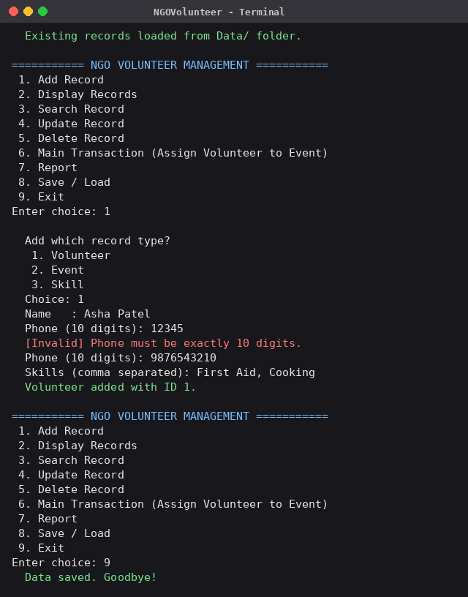
Screen 1: Adding a volunteer (invalid phone number rejected, then accepted)
● ● ● Screen 2 code: adding an event, date validation
// NGO.cpp
int NGO::addEvent(const string& name, const string& date) {
validateText(name, "Event name");
validateDate(date);
int id = events.nextId();
events.add(Event(id, name, date));
dirty = true;
return id;
}

// Utils.cpp
void validateDate(const string& s) {
// expected format DD/MM/YYYY
if (s.size() != 10 || s[2] != '/' || s[5] != '/')
throw ValidationException("Date must be in DD/MM/YYYY format.");
for (size_t i = 0; i < s.size(); i++) {
if (i == 2 || i == 5) continue;
if (!isdigit((unsigned char)s[i]))
throw ValidationException("Date must be in DD/MM/YYYY format.");
}
int d = atoi(s.substr(0, 2).c_str());
int m = atoi(s.substr(3, 2).c_str());
int y = atoi(s.substr(6, 4).c_str());
if (y < 2000 || y > 2100) throw ValidationException("Year must be between 2000 and 2100.");
if (m < 1 || m > 12) throw ValidationException("Invalid date (month must be 1-12).");
int days[] = {31, 28, 31, 30, 31, 30, 31, 31, 30, 31, 30, 31};
bool leap = (y % 4 == 0 && y % 100 != 0) || (y % 400 == 0);
if (leap) days[1] = 29;
if (d < 1 || d > days[m - 1])
throw ValidationException("Invalid date (day out of range for month).");
}

string readDate(const string& prompt) {
while (true) {
string s = readLine(prompt);
try { validateDate(s); return s; }
catch (ValidationException& e) { showInvalid(e.what()); }
}
}

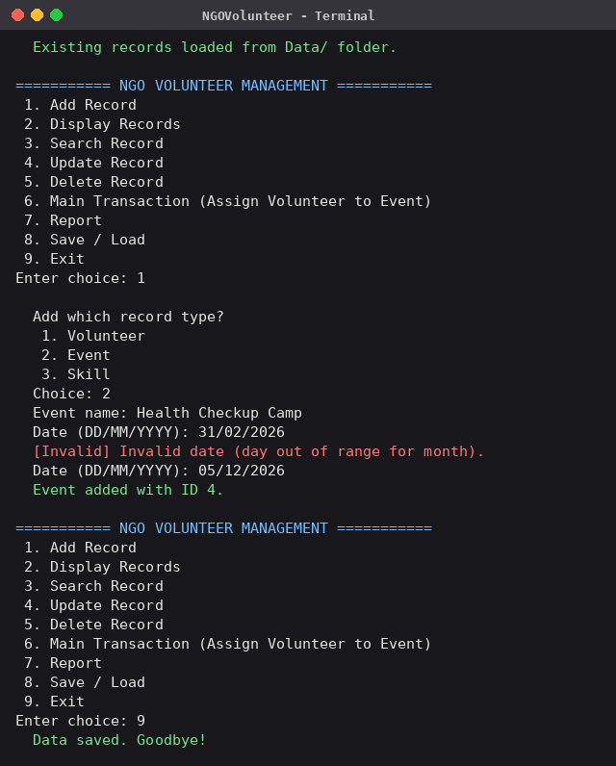
Screen 2: Adding an event (invalid date 31/02/2026 rejected)
● ● ● Screen 3 code: displaying records (runtime polymorphism)
// NGO.cpp
template <typename T>
static void showAll(const Store<T>& s, const string& title) {
cout << " --- " << BLUE << title << " (" << s.size() << ")" << RESET << " ---" << endl;
for (int i = 0; i < s.size(); i++) {
const Record* r = &s.at(i);
r->display(); // correct derived version runs
}
}

void NGO::menuDisplay() {
cout << "\n Display which record type?" << endl;
cout << " 1. Volunteer" << endl;
cout << " 2. Event" << endl;
cout << " 3. Skill" << endl;
cout << " 4. Assignment" << endl;
int t = readInt(" Choice: ", 1, 4);
cout << endl;
if (t == 1) showAll(volunteers, "Volunteers");
else if (t == 2) showAll(events, "Events");
else if (t == 3) showAll(skills, "Skills");
else showAll(assignments, "Assignments");
}

// Volunteer.cpp
void Volunteer::display() const {
cout << " ID: " << left << setw(3) << id
<< " | Name: " << setw(18) << name
<< " | Phone: " << phone
<< " | Skills: " << skills << endl;
}

// Event.cpp
void Event::display() const {
cout << " ID: " << left << setw(3) << id
<< " | Event: " << setw(24) << name
<< " | Date: " << date << endl;
}

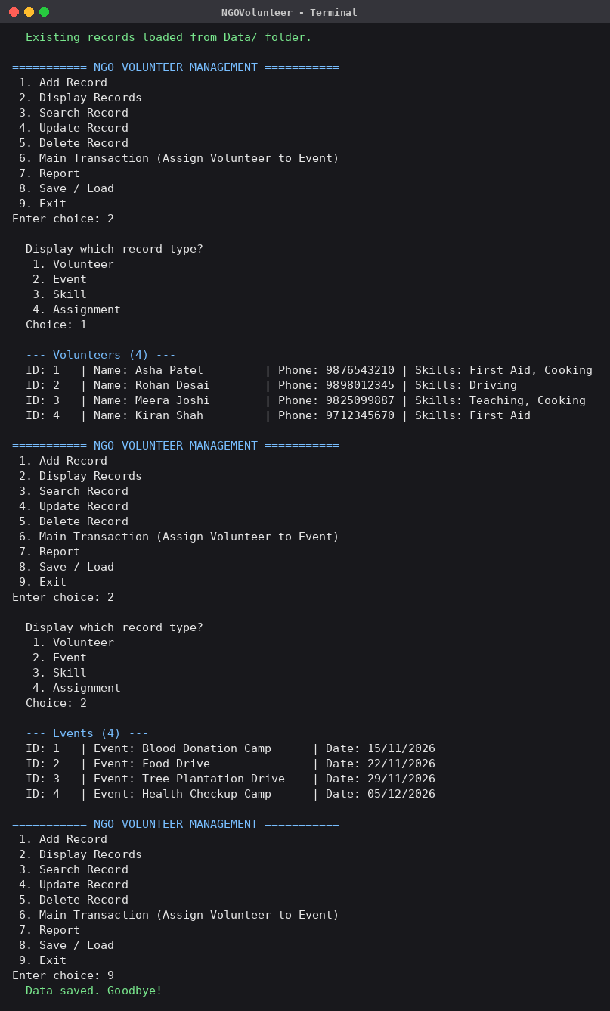
Screen 3: Displaying volunteers and events
● ● ● Screen 4 code: searching by keyword
// NGO.cpp
template <typename T>
static int searchStore(const Store<T>& s, const string& key) {
string k = toLower(key);
int found = 0;
for (int i = 0; i < s.size(); i++) {
const Record* r = &s.at(i);
string text = toLower(r->serialize());
string body = text.substr(text.find('|') + 1); // skip the id field
bool byId = (to_string(r->getId()) == key);
if (byId || body.find(k) != string::npos) {
r->display();
found++;
}
}
return found;
}

void NGO::menuSearch() {
cout << "\n Search which record type?" << endl;
cout << " 1. Volunteer" << endl;
cout << " 2. Event" << endl;
cout << " 3. Skill" << endl;
cout << " 4. Assignment" << endl;
int t = readInt(" Choice: ", 1, 4);
string key = readText(" Enter ID or keyword: ", "Keyword");
cout << endl;

int n = 0;
if (t == 1) n = searchStore(volunteers, key);
else if (t == 2) n = searchStore(events, key);
else if (t == 3) n = searchStore(skills, key);
else n = searchStore(assignments, key);

if (n == 0) cout << " No matching record found." << endl;
else cout << " " << n << " record(s) found." << endl;
}

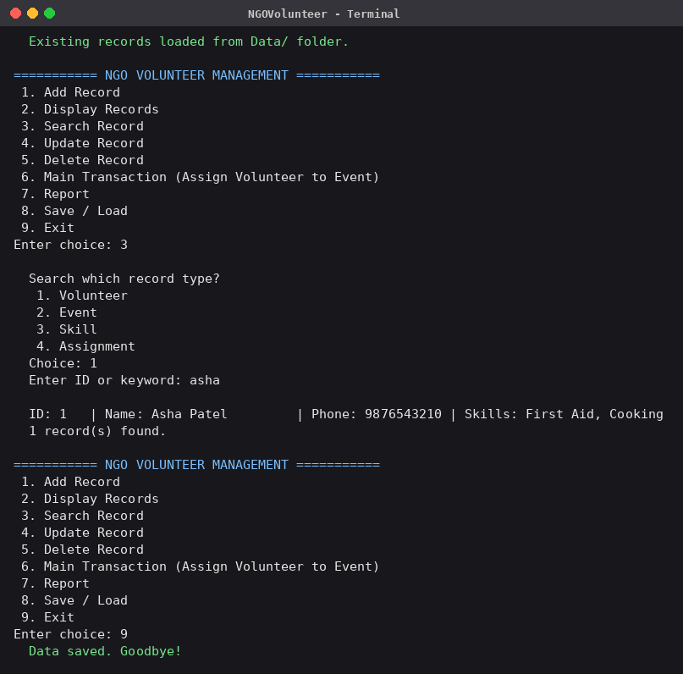
Screen 4: Searching for a volunteer by keyword
● ● ● Screen 5 code: main transaction (assign volunteer to event)
// NGO.cpp
void NGO::menuTransaction() {
if (volunteers.size() == 0 || events.size() == 0)
throw AppException("Add at least one volunteer and one event first.");

cout << "\n === ASSIGN VOLUNTEER TO EVENT ===\n" << endl;
showAll(volunteers, "Volunteers");
cout << endl;
showAll(events, "Events");

int vId = readInt(" Volunteer ID: ", 1, 999999);
int eId = readInt(" Event ID : ", 1, 999999);
string role = readText(" Role (e.g. Coordinator, Cook, Driver): ", "Role");

int id = assignVolunteer(vId, eId, role);
cout << GREEN << " Assignment created with ID " << id << "." << RESET << endl;
}

int NGO::assignVolunteer(int volunteerId, int eventId, const string& role) {
validateText(role, "Role"); // (1) role text

int vi = volunteers.indexOfId(volunteerId); // (2) IDs must exist
if (vi < 0) throw AppException("Volunteer ID not found.");
int ei = events.indexOfId(eventId);
if (ei < 0) throw AppException("Event ID not found.");

const string& newDate = events.at(ei).getDate();
for (int i = 0; i < assignments.size(); i++) {
const Assignment& a = assignments.at(i);
if (a.getVolunteerId() != volunteerId) continue;
if (a.getEventId() == eventId) // (3) duplicate
throw AppException("Volunteer is already assigned to this event.");
int other = events.indexOfId(a.getEventId());
if (other >= 0 && events.at(other).getDate() == newDate) // (4) same-date clash
throw AppException("Volunteer is already booked for another event on this date.");
}
Assignment a; // (5) create + store
a.setId(assignments.nextId());
a.setName("Assignment");
a.assign(volunteerId, eventId, role);
assignments.add(a);
dirty = true;
return a.getId();
}

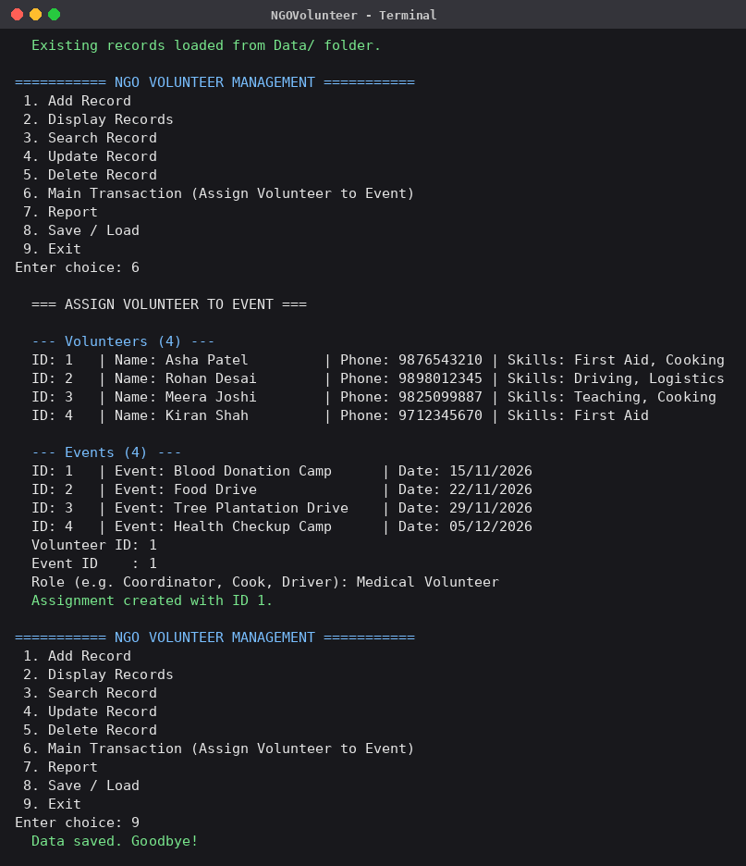
Screen 5: Main transaction – assigning a volunteer to an event
● ● ● Screen 6 code: duplicate check and error handling
// NGO.cpp : checks (3) and (4) inside assignVolunteer()
const string& newDate = events.at(ei).getDate();
for (int i = 0; i < assignments.size(); i++) {
const Assignment& a = assignments.at(i);
if (a.getVolunteerId() != volunteerId) continue;
if (a.getEventId() == eventId) // (3) duplicate
throw AppException("Volunteer is already assigned to this event.");
int other = events.indexOfId(a.getEventId());
if (other >= 0 && events.at(other).getDate() == newDate) // (4) same-date clash
throw AppException("Volunteer is already booked for another event on this date.");
}

void NGO::run() {
try {
if (loadAll())
cout << GREEN << " Existing records loaded from Data/ folder." << RESET << endl;
} catch (AppException& e) {
cout << RED << " [File Error] " << e.what() << RESET << endl;
cout << " Exiting without changing the data files." << endl;
return;
}

bool running = true;
while (running) {
try {
showMainMenu();
int choice = readInt("Enter choice: ", 1, 9);
switch (choice) {
case 1: menuAdd(); break;
case 2: menuDisplay(); break;
case 3: menuSearch(); break;
case 4: menuUpdate(); break;
case 5: menuDelete(); break;
case 6: menuTransaction(); break;
case 7: report(); break;
case 8: menuSaveLoad(); break;
case 9:
saveAll();
cout << GREEN << " Data saved. Goodbye!" << RESET << endl;
running = false;
break;
}
} catch (InputClosedException&) { // Ctrl+D / end of input
saveAll();
cout << "\n" << GREEN << " Input closed. Data saved." << RESET << endl;
running = false;
} catch (ValidationException& e) {
cout << RED << " [Invalid] " << e.what() << RESET << endl;
} catch (AppException& e) {
cout << RED << " [Error] " << e.what() << RESET << endl;
}
}
}

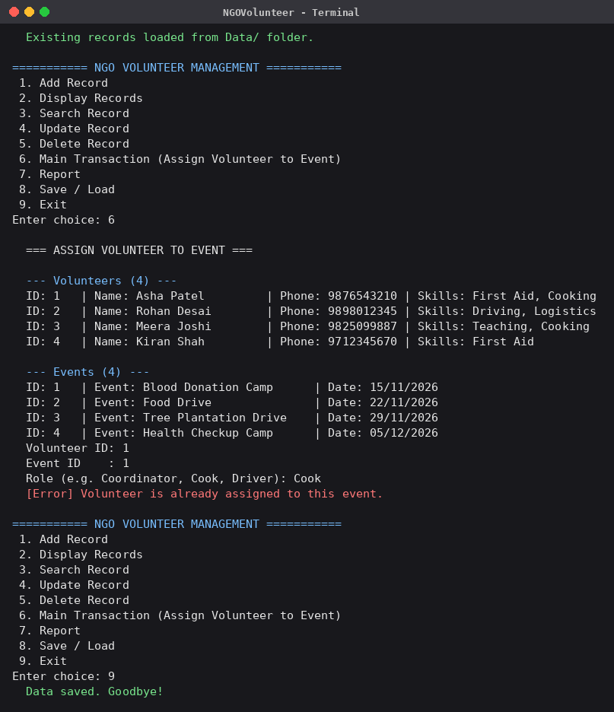
Screen 6: Duplicate assignment rejected
● ● ● Screen 7 code: report
// NGO.cpp
void NGO::report() const {
cout << "\n ========== NGO VOLUNTEER REPORT ==========" << endl;
cout << " Total volunteers : " << volunteers.size() << endl;
cout << " Total events : " << events.size() << endl;
cout << " Total skills : " << skills.size() << endl;
cout << " Total assignments: " << assignments.size() << endl;

// volunteers per event
for (int e = 0; e < events.size(); e++) {
const Event& ev = events.at(e);
cout << "\n Event " << ev.getId() << ": " << ev.getName()
<< " (" << ev.getDate() << ")" << endl;
bool any = false;
for (int a = 0; a < assignments.size(); a++) {
const Assignment& as = assignments.at(a);
if (as.getEventId() != ev.getId()) continue;
int vi = volunteers.indexOfId(as.getVolunteerId());
if (vi < 0) continue;
cout << " - " << volunteers.at(vi).getName()
<< " as " << as.getRole() << endl;
any = true;
}
if (!any) cout << " (no volunteers assigned yet)" << endl;
}

// volunteers with no assignment
cout << "\n Volunteers with no assignment:" << endl;
bool idle = false;
for (int v = 0; v < volunteers.size(); v++) {
bool used = false;
for (int a = 0; a < assignments.size(); a++)
if (assignments.at(a).getVolunteerId() == volunteers.at(v).getId()) {
used = true;
break;
}
if (!used) {
cout << " - " << volunteers.at(v).getName() << endl;
idle = true;
}
}
if (!idle) cout << " (none)" << endl;
}

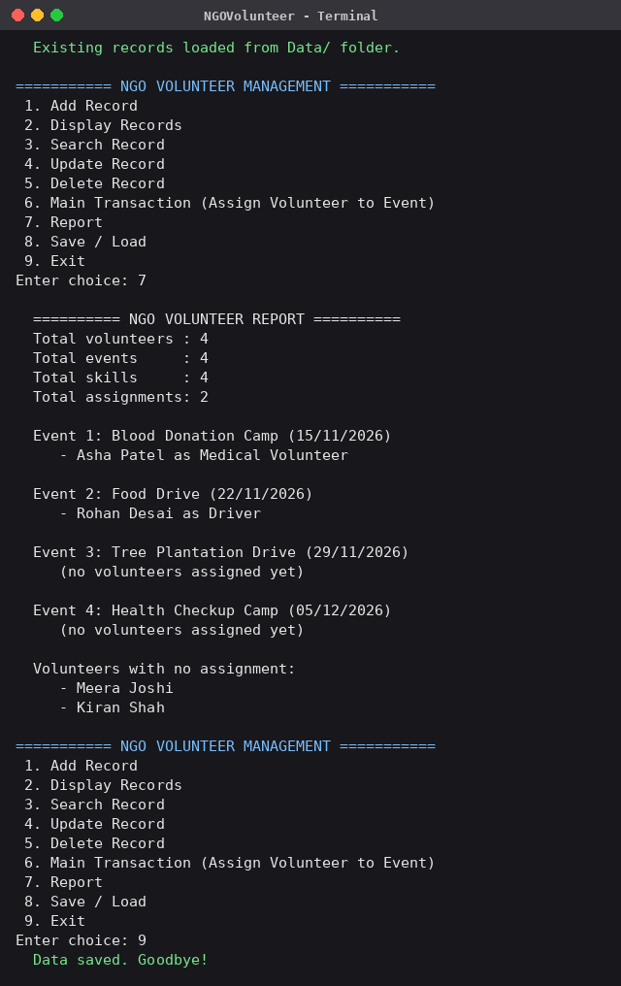
Screen 7: Report
● ● ● Screen 8 code: save and load (file handling)
// NGO.cpp
void NGO::menuSaveLoad() {
cout << "\n 1. Save to file" << endl;
cout << GREEN << " 2. Load from file (discards unsaved changes)" << RESET << endl;
int t = readInt(" Choice: ", 1, 2);
if (t == 1) {
saveAll();
cout << GREEN << " Data saved to Data/ folder." << RESET << endl;
} else {
if (dirty) {
string a = readLine(" You have unsaved changes. Load anyway? (y/n): ");
if (toLower(a) != "y") { cout << " Load cancelled." << endl; return; }
}
loadAll();
cout << GREEN << " Data loaded from Data/ folder." << RESET << endl;
}
}

void NGO::saveAll() {
FileManager fm("Data");
fm.save(*this);
dirty = false;
}

bool NGO::loadAll() {
FileManager fm("Data");
bool found = fm.load(*this);
dirty = false;
return found;
}

// FileManager.cpp
template <typename T>
static void saveStore(const string& filename, const Store<T>& s) {
ofstream out(filename.c_str());
if (!out) throw AppException("Cannot write file: " + filename);
for (int i = 0; i < s.size(); i++) {
const Record* r = &s.at(i);
out << r->serialize() << "\n";
}
if (!out) throw AppException("Error while writing file: " + filename);
}

template <typename T>
static bool loadStore(const string& filename, const string& shortName, Store<T>& s) {
ifstream in(filename.c_str());
if (!in) return false;
string line;
int lineNo = 0;
while (getline(in, line)) {
lineNo++;
line = trim(line);
if (line.empty()) continue;
T item;
Record* r = &item;
try {
r->deserialize(line);
if (s.indexOfId(item.getId()) >= 0) throw AppException("Duplicate ID");
} catch (AppException& e) {
throw AppException(shortName + " (line " + to_string(lineNo) + "): " + e.what());
}
s.add(item);
}
return true;
}

bool FileManager::load(NGO& ngo) {
// Load into a temporary object first, so a corrupt file can never
// leave the real data half-loaded.
NGO temp;
bool any = false;
any |= loadStore(path("volunteers.txt"), "volunteers.txt", temp.volunteers);
any |= loadStore(path("events.txt"), "events.txt", temp.events);
any |= loadStore(path("skills.txt"), "skills.txt", temp.skills);
any |= loadStore(path("assignments.txt"), "assignments.txt", temp.assignments);

for (int i = 0; i < temp.assignments.size(); i++) {
const Assignment& a = temp.assignments.at(i);
if (temp.volunteers.indexOfId(a.getVolunteerId()) < 0 ||
temp.events.indexOfId(a.getEventId()) < 0)
throw AppException("assignments.txt: assignment " + to_string(a.getId()) +
" refers to a missing volunteer or event");
}

ngo.volunteers.clear();
ngo.events.clear();
ngo.skills.clear();
ngo.assignments.clear();
for (int i = 0; i < temp.volunteers.size(); i++) ngo.volunteers.add(temp.volunteers.at(i));
for (int i = 0; i < temp.events.size(); i++) ngo.events.add(temp.events.at(i));
for (int i = 0; i < temp.skills.size(); i++) ngo.skills.add(temp.skills.at(i));
for (int i = 0; i < temp.assignments.size(); i++) ngo.assignments.add(temp.assignments.at(i));
return any;
}

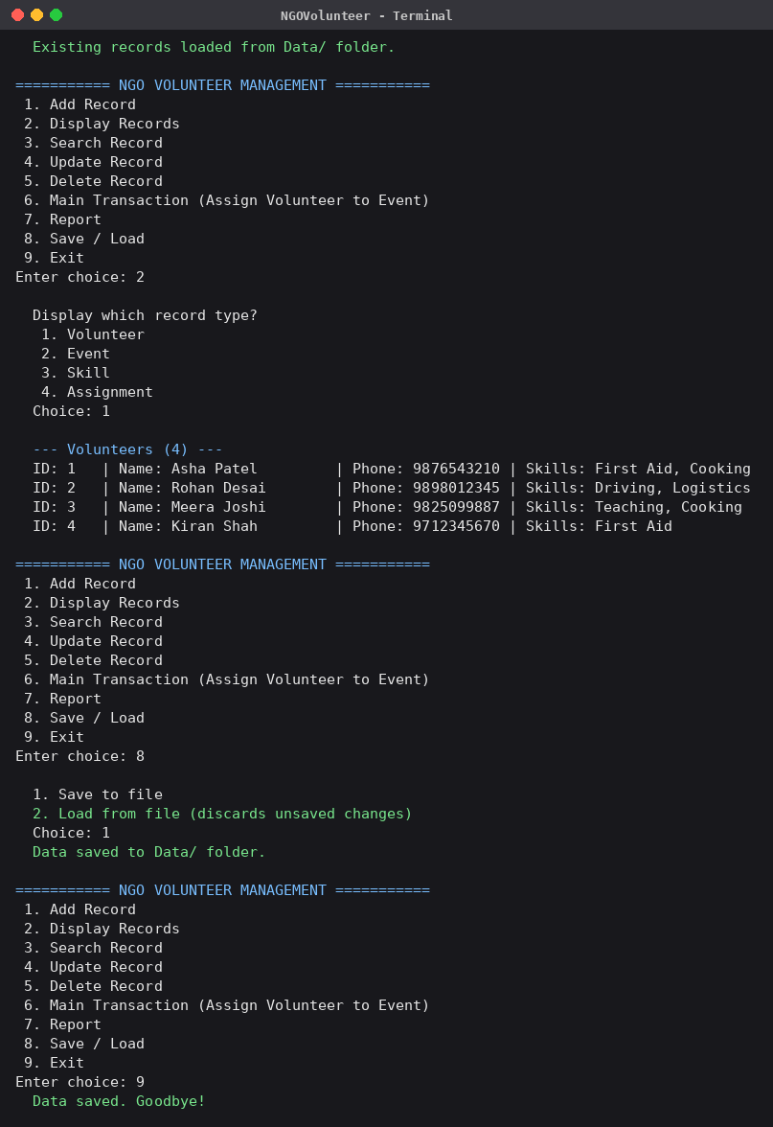
Screen 8: Program reopened – old records loaded from file

13. Limitations
- It is a console application without a graphical interface.
- Data is stored in plain text files; there is no database, encryption or multi-user access.
- Skills in a volunteer record are free text and are not linked by ID to the Skill list.
- Only one NGO and one administrator are supported; there is no login.
- Events are checked only by date, not by start and end time.

14. Future Scope
- Add a graphical interface (Qt) or a web front end.
- Move storage to a database such as SQLite or MySQL.
- Add login with admin and coordinator roles.
- Link volunteer skills to the Skill list and suggest suitable volunteers for each event.
- Send e-mail or SMS reminders and export reports to PDF/CSV.
- Track volunteer hours and generate certificates.

15. Conclusion
The NGO Volunteer Management system successfully meets the requirements of the guided project. It demonstrates classes and objects, encapsulation, constructors and destructors, inheritance, runtime polymorphism, dynamic memory, file handling, validation and exception handling in one working application. All 15 test cases pass, data persists between runs, and the code is organised so that new entity types or features can be added easily. The project gave practical experience in designing with UML, structuring a multi-file C++ program and testing it systematically.

